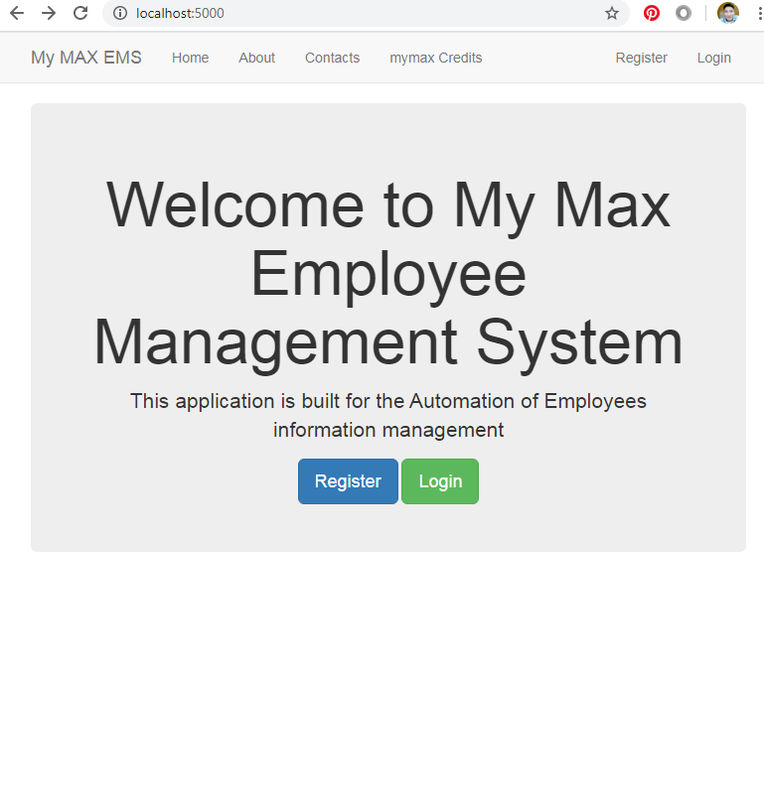

My max Employee Information and Data Management System – MyMax ECMS

Data Analyst @ MAX group

Nyam-Ochir Bold

|  |  |  |  |  |  |
| --- | --- | --- | --- | --- | --- |
| Home Screen general info of the web site and platform  Two back end process can be chosen in home page(100% completed) | General info no back end operation(100 % completed) | Staff members  For contact()  Data integration will be done- 70 percent(20% GUI,  80% back end) | Zeeliin tootsoolol harah  All calculation are Back end  (90%completed) | Login and Register button can do modification in the database | Search bar will be added  (0% completed) |
|  |  |  |  | Registration and Login form are 90% completed  Database setting will be made in this week. | Completed, in this week |

Database

Data Extraction by several query options.

Core Credit Computation Engine

Anket data Table

Ungursun sariin suutgal

Table

Barimtiin

jagsaalt

Modification from the website

Table

Non critical information containing local variables

Data container directory not in DB

Credit Computation Engine

1. Search ID
2. Data matching from 3 tables.
3. Saved calculations
4. Collections
5. Template table row return

Quality check and assurance of the data.

**Data combiner engine**

Deployment Website

Free server launch

Expected to have more--> non free service

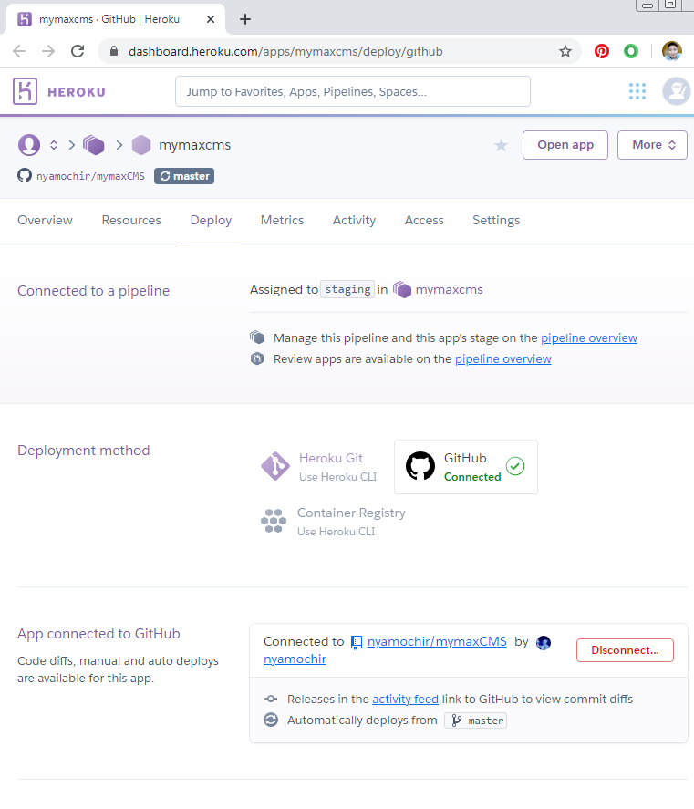

This is not just a website, this the project that can build full of possibility in the future to develop strong API management system throughout the group.

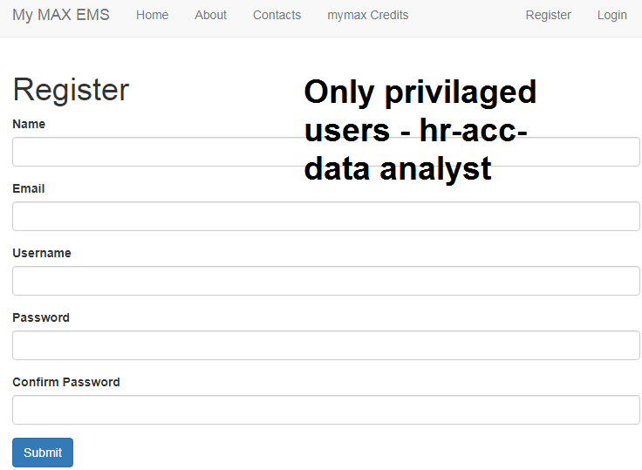

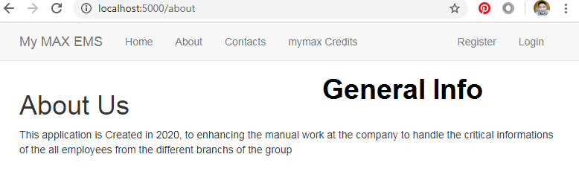

Copy right and other information and also functionality will be added accordingly

Platform will be under use test by 31st Jan 2020